**Devops Assignment 1**

1-update the Centos Machine:

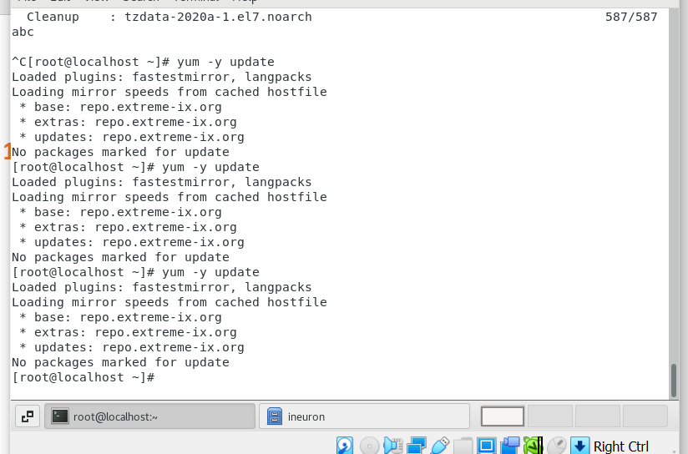

Assignment 2: Install all the dependencies for making CentOS full screen-

Step1- yum -y install gcc – its stand for GNU Compiler Collection

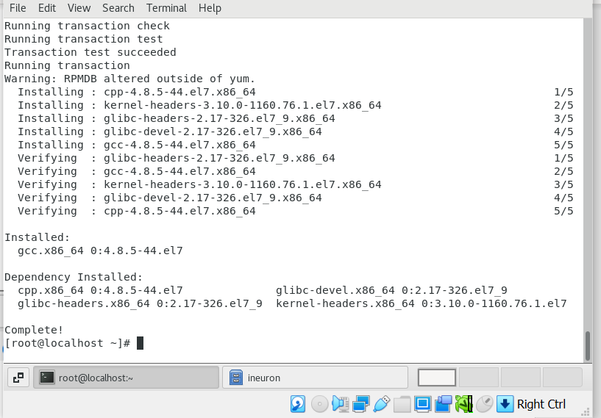

2: yum install make perl -

Its already completed because I recently update Centos

Step3- yum install kernel-devel $(uname -r)

For installing kernel

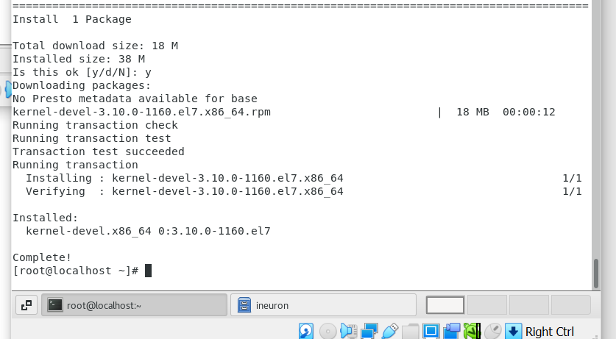

Step4- update the kernel and restart device with latest kernel

Assignment-3

**Connect and disconnect with login Access**

**● What happens when you login a non-existent users or username?**

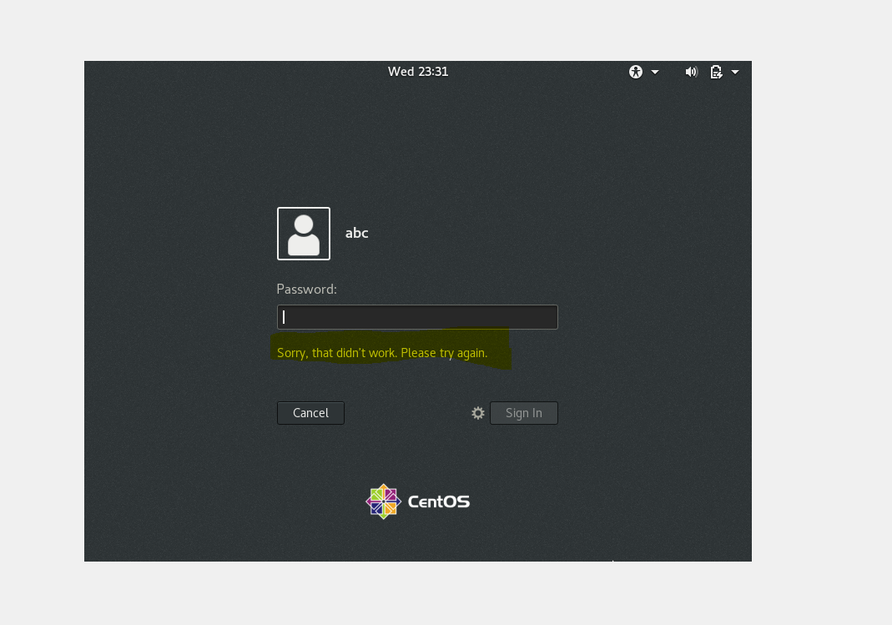

It shows it’s didn’t work because ABC is not a user.

Assignment-4

Password changing

● Login into your account and then change password? o Change your password into IneuR0n#42 and hit the Enter key

Step 1: command used- passwd

Step 2- enter current password

Step 3- enter new password

Step 4- enter new password again

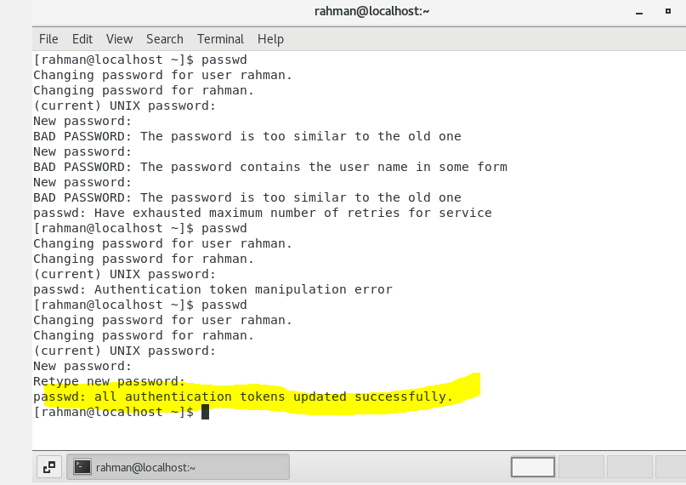

Password is change as IneuR0n#42 for user Rahman.

**Try again to change password but use like password 1234 or abcd:**

step 1: command – passwd

step 2: enter current password

step 3: enter new password as abcd

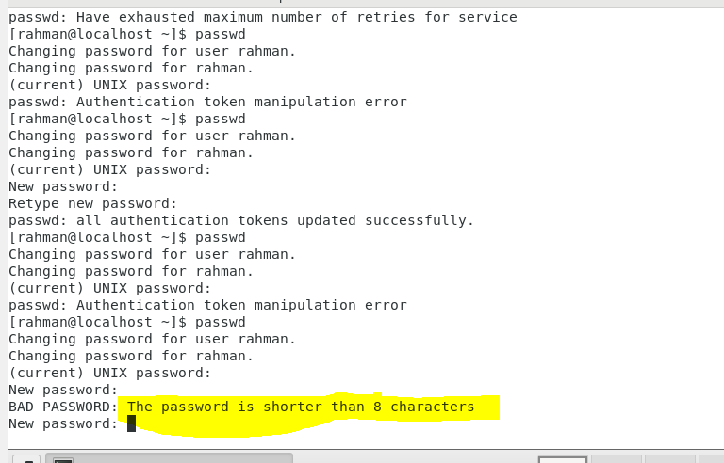

--🡪> it shows that minimum password length is 8 characters.

**Try again to change password but now don’t use any password just hit Enter key:**

Step 1: command passwd

Step 2: enter current passwd

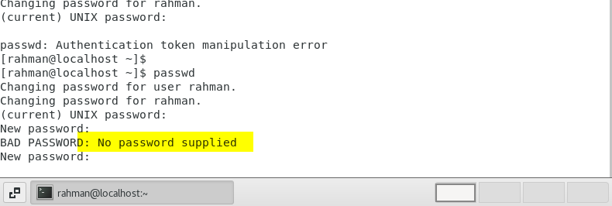

-🡪> it shows that no password supplied that means password is empty

Assignment-5

**Working with Directories**

**● Enter the command cd / and then ls and then hit Enter key**

Step 1: command cd /

Step 2 – command ls

* After using first command we are in root directory
* And us ls we got all directory available in root

**Enter the command now cd /home and then hit Enter key**

**o Do ls,**

step 1: command cd /home

step 2: command ls

🡪after using cd /home we are in home directory

🡪after using ls, it show the available directory in root

🡪/home directory is used for contains personal file and data

**Enter cd .. and hit Enter key**

Step1: command cd ..

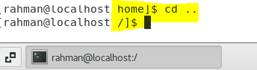

🡪after using cd .. we rollback one directory

**Now enter cd /var/www/html and then type cd and hit Enter key:**

**Step 1: command cd /var/www/html**

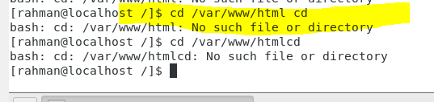

🡪it shows no file and directory that means there is no directory of this name

**Now type cd /root and then hit Enter key:**

**Step 1: command cd /root**

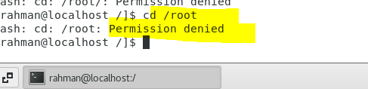

* **Permission denied**

Assignment-6

**Working with File List:**

Go to cd /etc and type ls

Step1: command cd /etc

Step 2: command ls

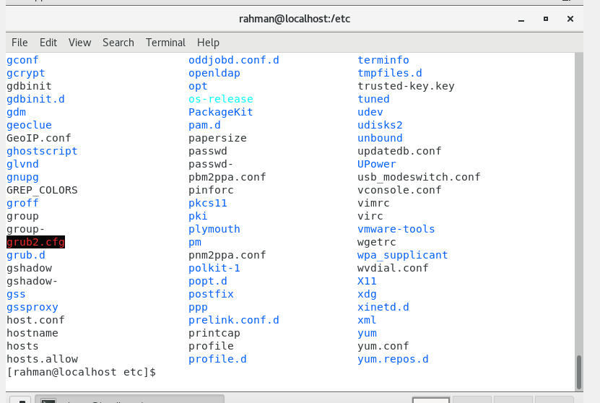

🡪after using cd /etc we move to etc directory

🡪after ls it show all directory

🡪it’s different to past command because /etc file have all config file

**Then type ls -al and hit Enter key:**

step 1:command ls -al

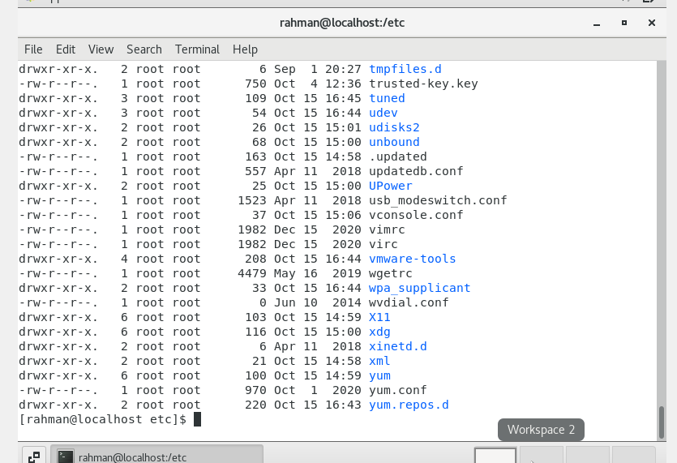

🡪it shows all downloaded file and its permission and date and space covered and which directory its belong to

**use ls -i and hit Enter key:**

step 1: command ls -i

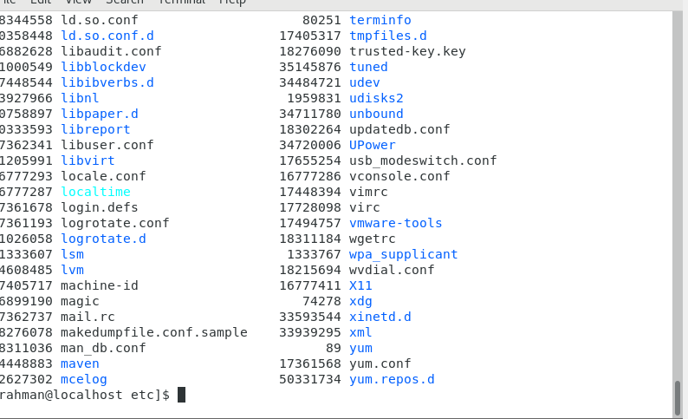

🡪It shows index number of all file

Assignment-7

**Know where you are and where you working;**

**USE PWD:**

Step 1: command pwd

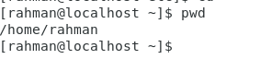

🡪it show’s present working directory where you work currently

**Now use cd /var and hit Enter key:**

Step 1: command cd /var

Step 2:command ls

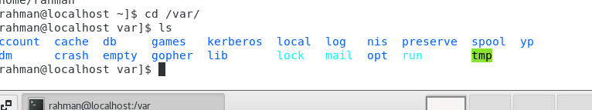

🡪after using cd /var we are in var directory

🡪after using ls it show all file available in var

🡪in var directory we have administrative and loging data